CACTAS Release Notes – May 11th 2023
Contents
PI View Access 1
Additional Ways to View/Download Files 2
Updates to the Folder Page 4
New Task List on Home Page 4
Email Displayed when Searching Contacts 4
Sponsor (Accounts) Page Updates 5
Hover Text Updates 5
Add Title in the Search Display Results 6
Expanded Notes Field on Agreement Page 6
Intake Form Changes 6
Updates to Subaward Agreement Record 7
Updates to Subcontractor Page 7

PI View Access
Principal Investigator (PI) have view access to their own records.
- When a PI is added to the Principal Investigator field, that individual will automatically be given read-only access in CACTAS. Their access will be restricted to only those records where they are listed as the PI.
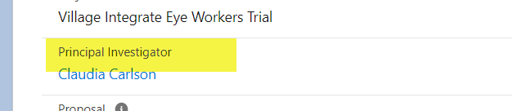

Additional Ways to View/Download Files
There are three ways to View/Download Fields
- Agreement Page
  - Click on the Downward arrow button on the far right under the External Uploaded Files section
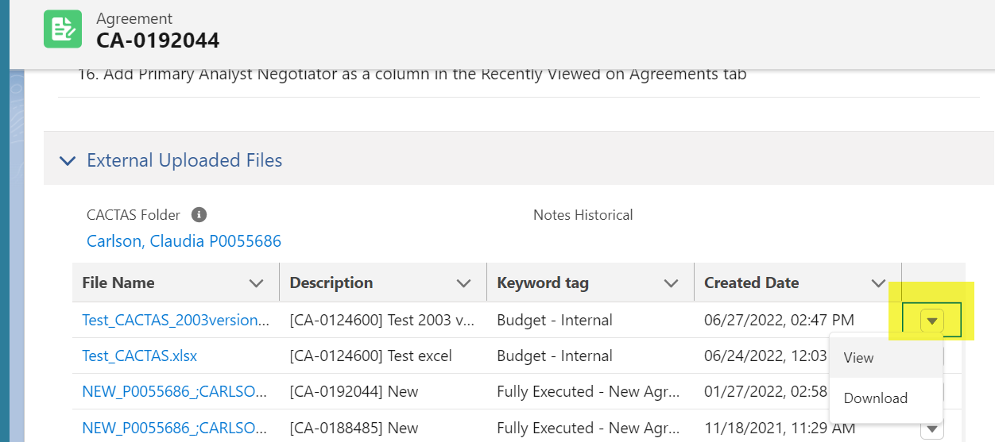

- File Page
  - To access the file page, click on the file name on the Agreement page under the External Uploaded Files
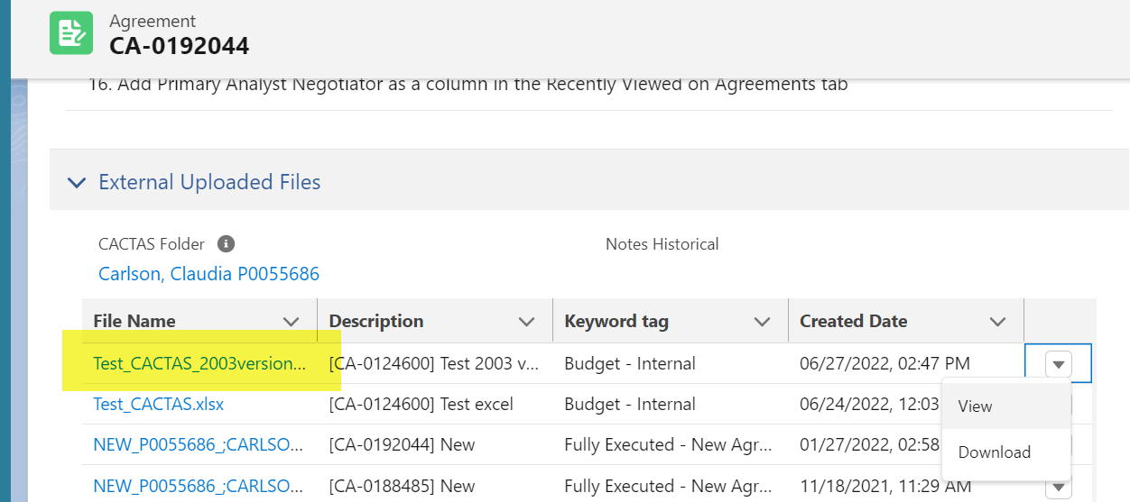
  - On the file page, click on “Download Latest”
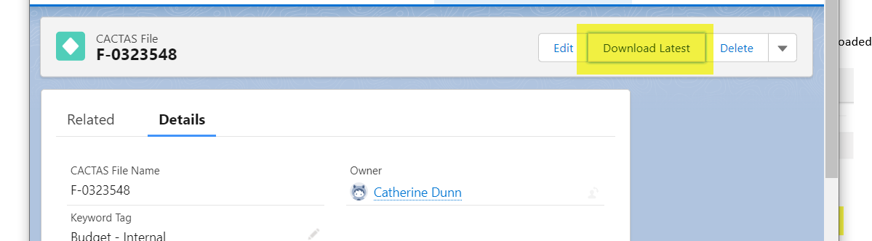

- Folder Page
- To access the folder page, either:
    - Click on the folder name on the Agreement page under the External Uploaded Files
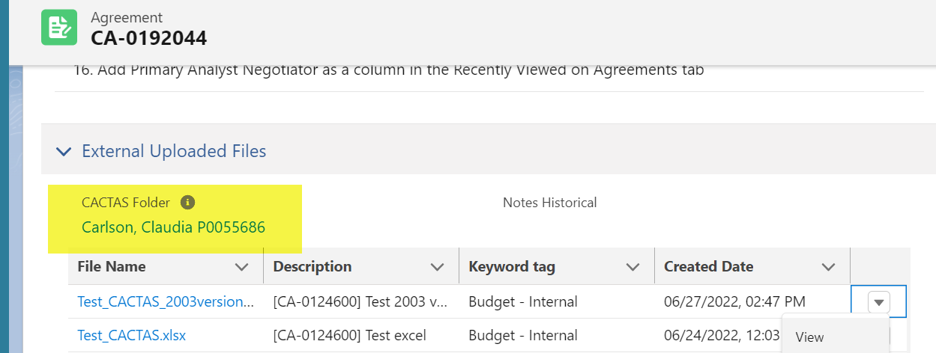
    - Click on folder name from a search result

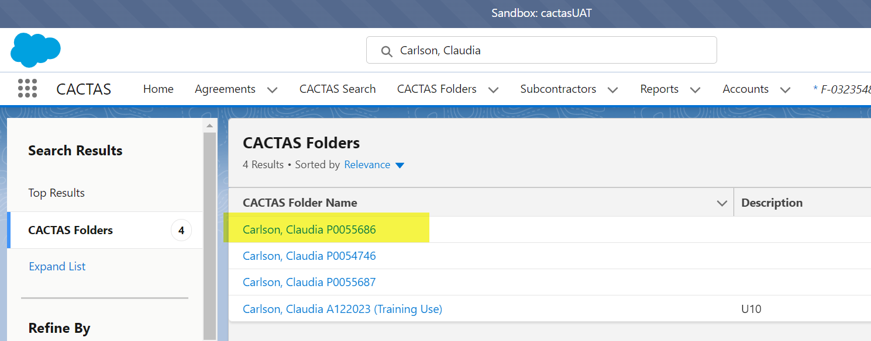
- On the Folder page, click on the Downward arrow button on the far right under the External Uploaded Files section
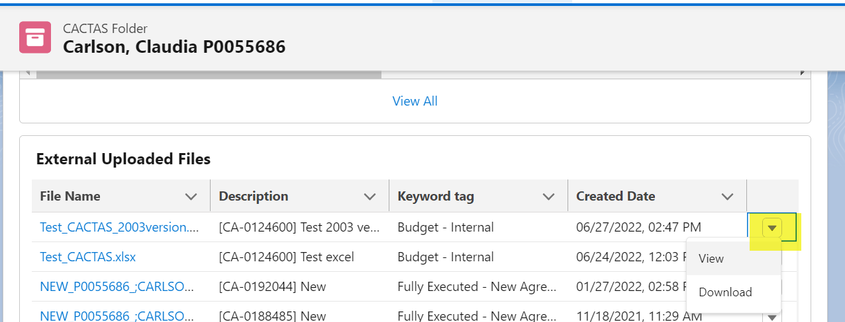

Updates to the Folder Page
New details have been added to the Agreement list view on the Folder Page
- Columns added: Action Type, Status, Subcontract Status and Created Date
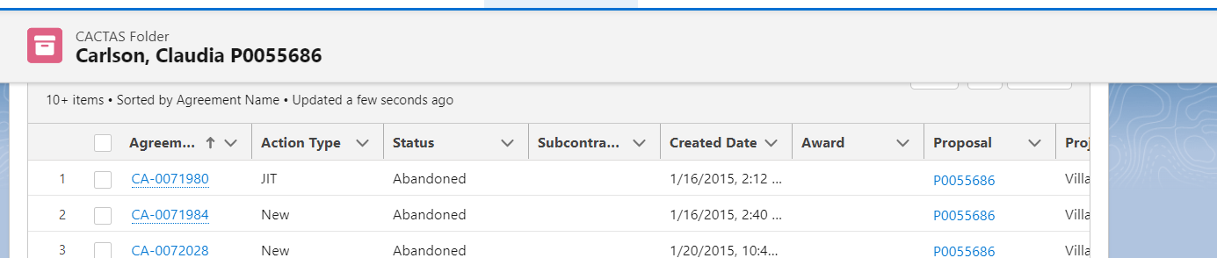

New Task List on Home Page
A default view of pending task displays on the home page. Click on More for full task list and more details.
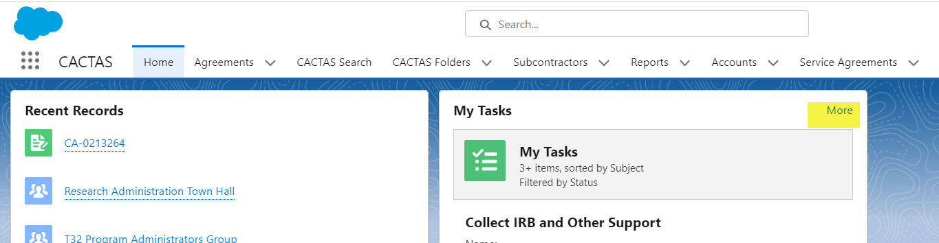

Email Displayed when Searching Contacts
When searching for a contact, email address will show under the name to allow for distinguishing between individuals with identical names.
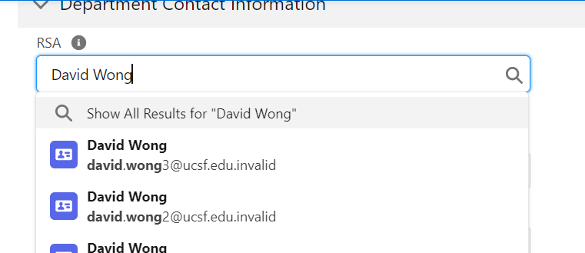

Sponsor (Accounts) Page Updates
- The CACTAS Feed (Chatter Tab) will appear as default in the right corner of the Sponsor (Accounts) Page

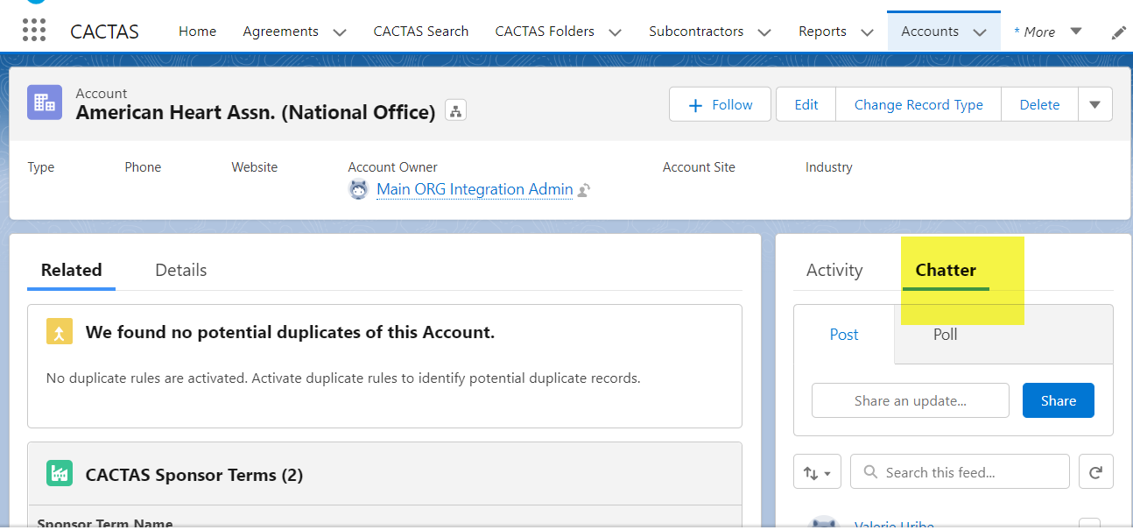

Hover Text Updates
- Sponsor Code Appear when hover of Sponsor in agreement
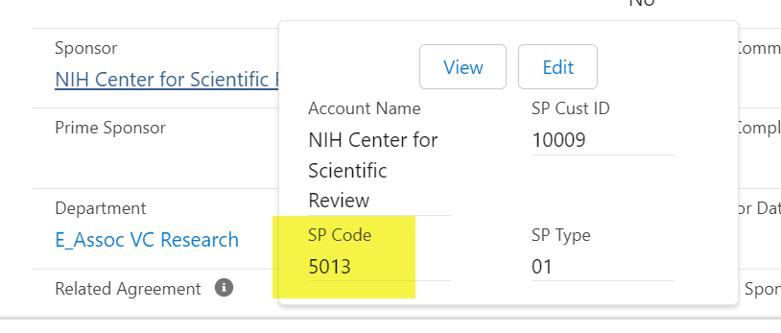
- Employee ID for all People/Contact fields
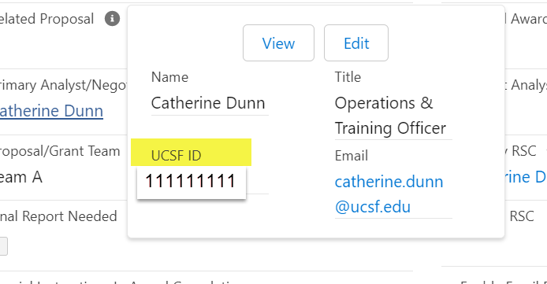

Add Title in the Search Display Results
Project Title has been added as a column in the display results when using the CACTAS Search tab
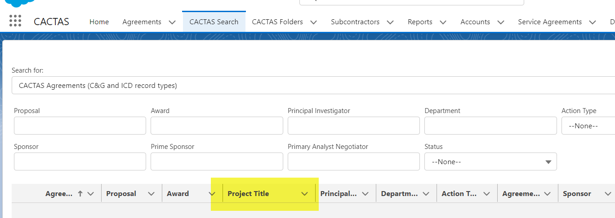

Expanded Notes Field on Agreement Page
Expand Space for notes fields – can be expanded down but not out – Is this even possible?
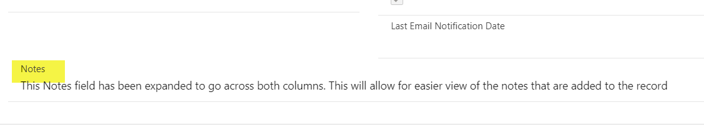

Intake Form Changes
Renamed the Budget form names to Budget-Internal and Budget-Sponsor and removed Proposed Project Budget
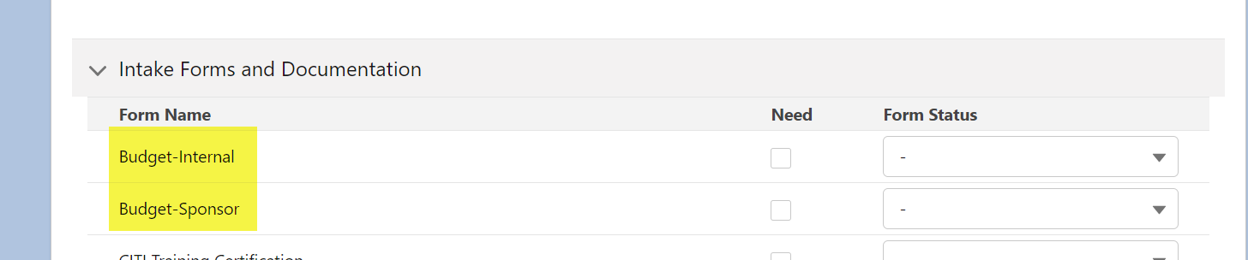

Updates to Subaward Agreement Record
Information Section:
- Update “Department Contact” to “Financial Contact”
- Text box “Additional UCSF Contacts” under Department Contact
- Text box “Additional Sub Contacts” under Sub Contact Email

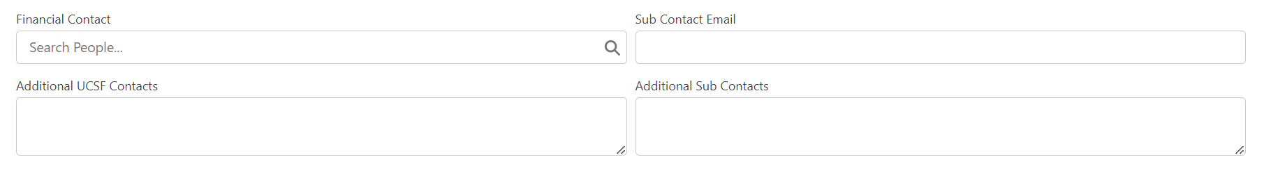

Updates to Subcontractor Page
Subcontractor Profile Section
- “Additional Sites” text box under “Sub Website”
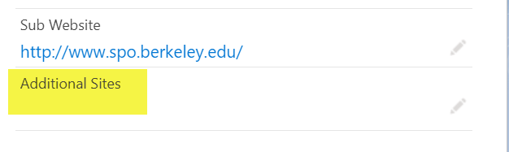
- “Common Name” text box under “Legal Name”
