CACTAS Release Notes (11/17/2021)
- Lightning Interface
- Global Search
- New Search Tab
- Creating Views
- New Agreement Page Design
- View/Download a File
- Intake Form and Documentation – C&G and ICD Records
- New Fields – C&G and ICD Records
- New Validations
- Updates to Dropdown list – C&G and ICD Records
- Other Updates
- Home Screen
- Footer Updates
- Subcontract Record Updates
- Subcontractor Updates

Lightning Interface
The CACTAS platform has been updated to the Salesforce Lightning User Interface. The first time you login you may need to “Switch to Lightning Experience” by clicking in the upper right corner of the screen.
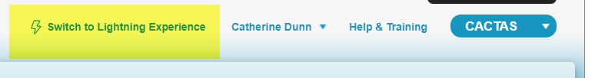
To switch between different Salesforce platforms (Chatter, CACTAS, PSA/TAA) select the square of dots in the upper left corner

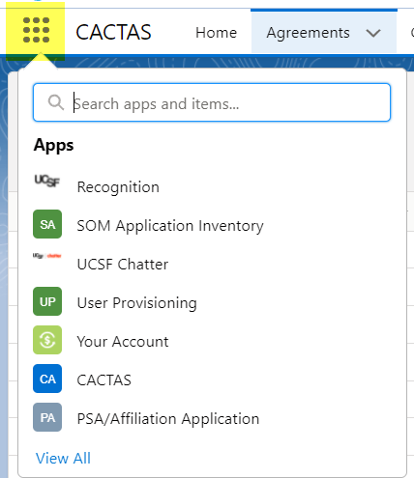

Global Search
Use the top Global Search field at the top to search across CACTAS Records, Files, Folders, Sponsor and more.
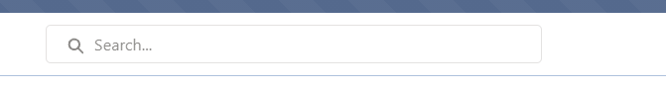
- To narrow the search, select the item to be searched by clicking in the search field then selection from the dropdown on the left. It will default to all
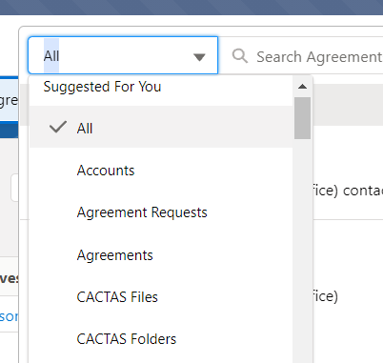
  - Accounts = Sponsor
  - Agreements = CACTAS records
  - Agreement Requests = PSA/TAA requests (restricted to those that have PSA/TAA access)
- All fields withing the CACTAS record are searchable; however, the columns of the search results are limited.
- For example, Search Agreements for “Carryover”, the results will be all agreements that have the word “Carryover” somewhere within the record.
  - Search “Carryover”
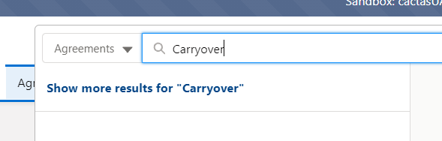
  - Search Results:
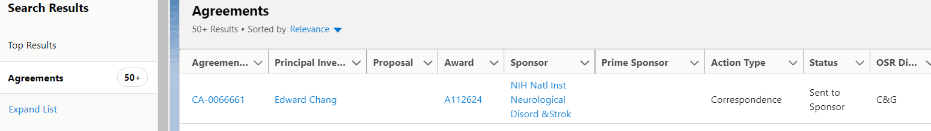
  - “Carryover” is in the Correspondence Type field of the CACTAS record
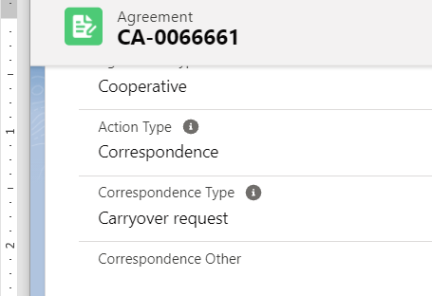
- Filter further on the results screen by using the “Refine By” fields on the left
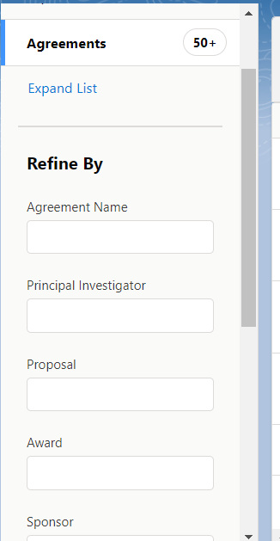

New Search Tab
The new search tab will only search within CACTAS record based on the fields provided.
Switch between C&G and ICD record types with Subcontract record types. The filter fields vary depending on type of records being searched.
The new search tab using dynamic searching: search begins once typing within a field begins. Multiple fields can be used to narrow the search results. Columns are sortable by clicking on the title at the top of each column.

Creating Views
All views created in Classic CACTAS will be available in the new Lightning version. Follow the following steps to create a new view.
- On the Agreement page, select “New” underneath the List View Controls dropdown.
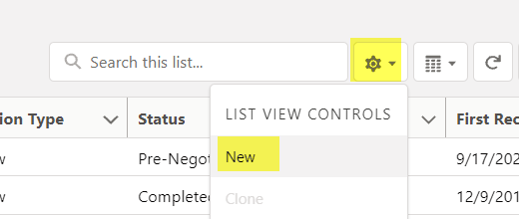
- Create a List Name and select save. The only option available is “Only I can See this list view”. The options to share list views are greyed out for all users.
- In the right side column, update Filter by Owner to “All Agreements”
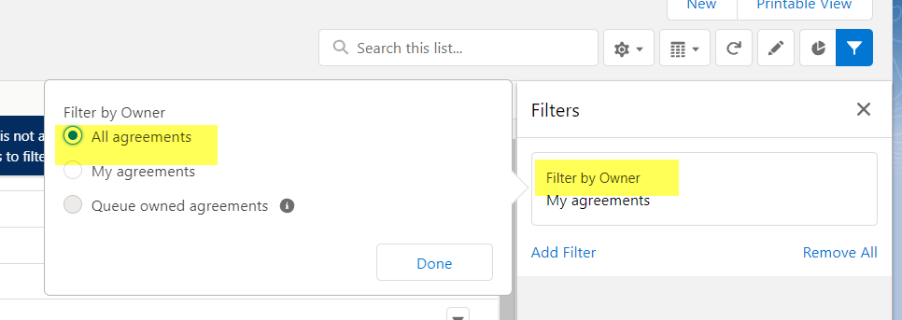
- Add new filters. Select the field form the top dropdown box. Select Operation and then value.
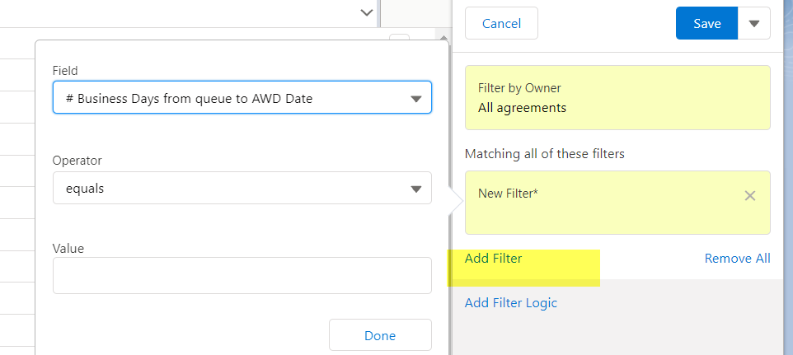

- To control the results that are displayed, select “Select Fields to Display” from the List View Control Dropdown
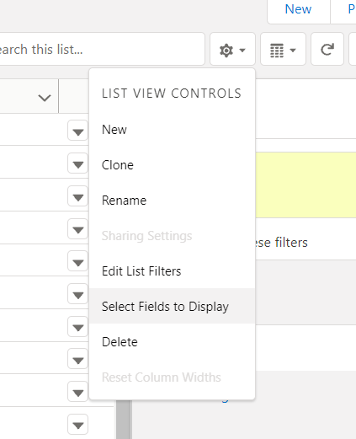
Multiple views can be created and selected from the dropdown. Any list can be “Pinned”. The Pinned list automatically displays as default.
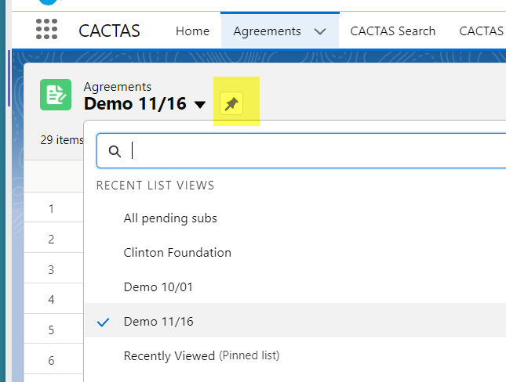

New Agreement Page Design
- New Right Side Panel
  - Intake Form and Documentation
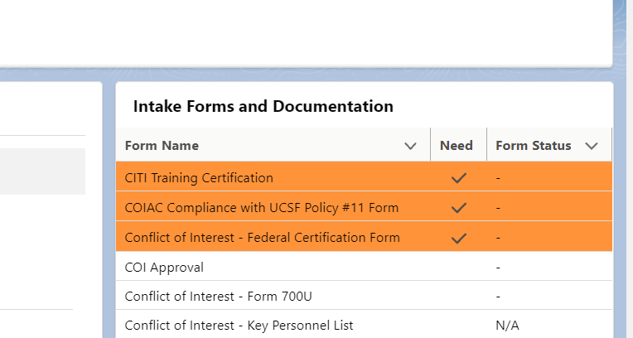
  - Activity – Emails, New Tasks, Log a Call
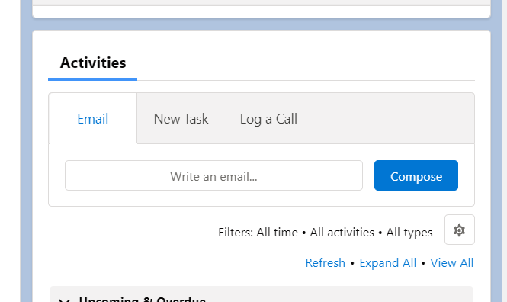
- Related Tab
  - Agreement History
  - Related Agreements
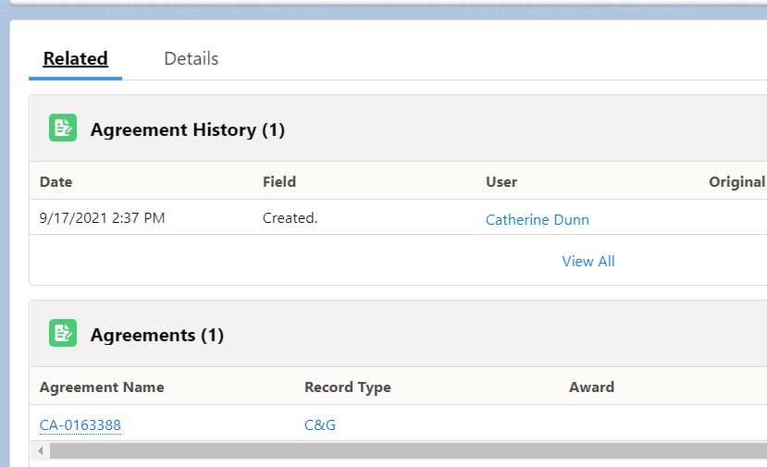

View/Download a File
View and Download files from the Folder section of the Agreement. Do not click on the File Name Link, this takes you to details about the file but we will not be able to view or download.
Go to the Arrow on the far right of the entry in the folder, and either select View or Download.
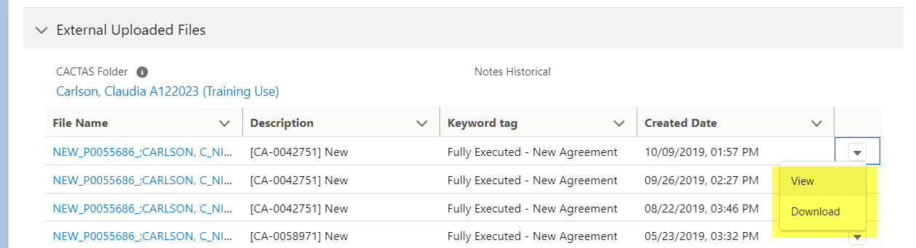

If you select View, you will still have the option of downloading on the resulting screen, along with other actions.
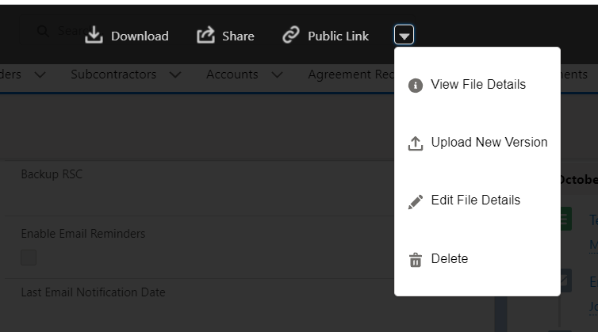

Intake Form and Documentation – C&G and ICD Records
- Merged the old ICD and C&G Intake forms into one list
- Added additional compliance items
  - Enterprise Information and Analytics (EIA)
  - Export Control
  - IT Security
  - PI/Dept Chair Informed Consent
  - Review by Other UCSF Unit (OTM/Risk/EHS)
- Tracking Dates based on when “Need” and “Have” are selected.
  - Start Date when Need is selected
  - End Date when Have is selected
  - Dates to be used when running reports, do not show on an individual agreement page

New Fields – C&G and ICD Records
New Budget Fields
To be used if the breakdown of direct and indirect costs are not clearly defined in the Award Document. Located in the Award Setup Notes Section.
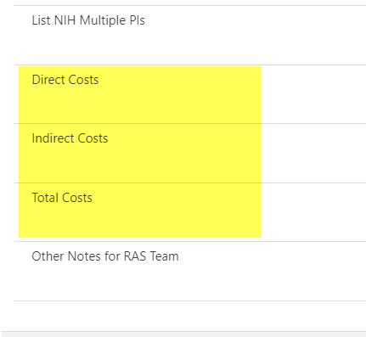
Correspondence Other
To be filled in when “Correspondence Type” is Other. Located in the Summary Section.
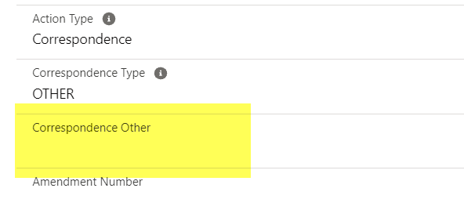
CGA Staff # -
Dropdown to be used by CGA. Located in the Summary Section
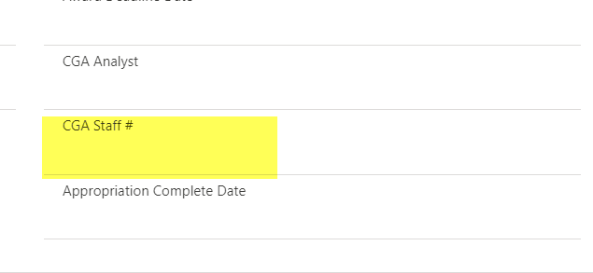

Proposal/Grant Team
RMS Team is replaced with Proposal/Grant Team located in the Information section.
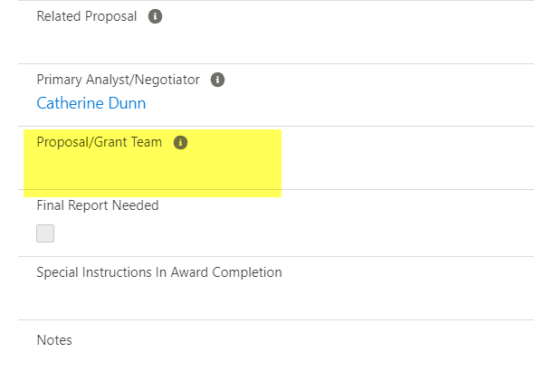

Updates to Dropdown list – C&G and ICD Records
Upload new file – Key word Tag
Following Removed:
- Award Completion Form
- JIT
- OSR Approval Form
- Proposal (After the Fact)
- Proposal (Complete Package)
Following Added:
- Protocol
- Subaward Request Form
- Scope of Work
- eProposal Questionnaire
- eProposal Approval
Correspondence Type – C&G Record type only
Following Removed:
- Post-Submission Material
Status
Following Added:
- Under Negotiation – UCSF
- Under Negotiation – Sponsor
OSR Division
Changed to:
- Award
- Business Contracts
- Government Contracts
- Industry Contracts Division
- Proposal/Grant
Agreement Type
Following Added for C&G Record Types:
- UCSF Funded Research Agreements

New Validations
- Required Fields has *
- When hit save, scroll up to find error messages

A. If Agreement types is one of the following and there is a date in Award Setup Queue give an error message and do not allow record to be saved.
For both ICD and C&G records.
Agreement Types
- Business Associate, CDA
- Consulting Agreement
- Equipment Loan
- External Recharge, LOI
- Memorandum of Understanding
- MTA (all)
- Sales and Service
- Sub-out (all)
- Service/Business Contracts
- DUA (all)
Error message:
Award Set-Up Queue Date: Remove date from Award Setup Queue field. This Agreement type does not go to CGA.

B. Existing validation removed:
Previous Functionality that is now removed: For ICD record type, when a date was entered into Compliance doc “Completed Date”, it auto converts anything in intake form documentation from “need” (checkbox) to “have” (“Form Status” drop down) AND updates status to “Compliance docs completed”.

Other Updates
- Department Field autofilled based when Principal Investigator field is completed.
  - Department based on home department of PI
  - If Proposal field is completed, department will be completed based on Proposal Record
- Project Title displayed in hover text when adding to Proposal and Award Fields
- Last Modified field updates anytime a user saves the record. It will no longer be updated based on automated system updates

Home Screen
Displays Recent Agreement and My task

Footer Updates
- Link to Training Resources – goes to the OSR public site page
- Dept Report Filter – can be used for reports and views to create an list of “children” Dept IDs that can copied

Updates to Subcontract Record types
New Fields:
- Estimated Total Amount located in the Subcontract Request Section.
- Estimated End Date located in the Subcontract Request Section.
- Prime Sponsor located in the Prime Award Detail Section
Validations:
- Project Id required only when Subcontract Action Type = “new” and Subcontract Status = “Sub Request Complete”
- Award required only when Subcontract Status = Sub Request Complete

Updates to Subcontractor page
New Fields:
- Audit Fiscal Year End Date located in Risk Assessment Section
- Change title of field from SAMMI ID to Sub UEI located in the Subcontractor Profile Section

