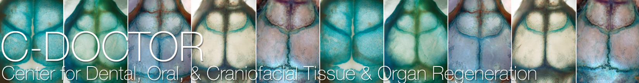

Interdisciplinary Translational Project Program, Cycle 2 (Winter 2017/2018)

Pre-Proposal

Project information
Applicant name (Last, First):
Project Title:
Project summary (300 words of less)
Please submit your application at https://cdoctor.submittable.com/submit
Applications are due on January 12, 2018 by 5pm (Pacific)

Please use the template provided on the following pages for the Research Strategy, and use no smaller than Arial 10pt. Altogether, the responses to questions 1-4 should not exceed 2 pages, exclusive of the References. Biosketches of the PI and all key personnel should be uploaded separately in PDF format.

- Significance
Describe the unmet clinical need in the dental, oral, craniofacial (DOC) space and market opportunity to be addressed by the proposed technology/solution, as well as the potential for clinical adoption.
- Which specific patient population/market segment is addressed?
- What is the current standard of care? What other approaches exist to solve this clinical need?
- What are the needs from the various stakeholder’s perspective (end user/patient, clinician, payer, etc)?

- Innovation and impact

Provide a clear and concise description and the innovation surrounding the approach.

• What is the current stage of the technology?

• Describe early target validation or proof-of-concept data

- Competition
- What is the current stage of translational development? (small animal, large animal, pre-IND meeting?)
- What is the current IP status of this technology (provide information related to disclosure to your Technology Transfer Office, patent status, licensing details)?
- What is the overall commercialization/translational plan for this technology?

- Work plan strategy and aims
Describe the plans and goals to be accomplished during the funding period. Discuss how the successful achievement of these goals will motivate the next stage of development (e.g., pre-submission meeting with FDA).
- What key experiments are proposed to further demonstrate commercialization/clinical translation potential of your technology? How does the successful completion of these proposed plans bring the proposed technology/solution closer to clinical/commercial translation?

References

